**CSCI 1302**

**Mid-Term Review**

**Numberic Converions**

Be able to convert: Decimal to Binary, Binary to Decimal, Hex to Binary, Binary to Hex

Languages: page 7

* Machine Level: Binary language
* Low Level: Assembly language, Byte Code
* High Level: Java language

Know: pages 11 & 16

* API: Application Program Interface: the Java syntax is defined here and the Java Library is defined here
* JDK: Java Development Toolkit: the software for developing and running java programs
* JVM: Java Virtual Machine: interpreter that runs the Bytecode
* Compiler: transforms the entire source code (high-level language) as a single unit into another code (such as Bytecode) or machine level language
* Interpreter: executes programs line by line, like the JVM translates the Bytecode line by line into machine code (binary language)

Which does Java use – compiler or interpreter? pages 15 - 17

Both: Java source code --> compiles into Bytecode -->JVM (interpreter)

Know the diagram: page 17, Figure 1.8

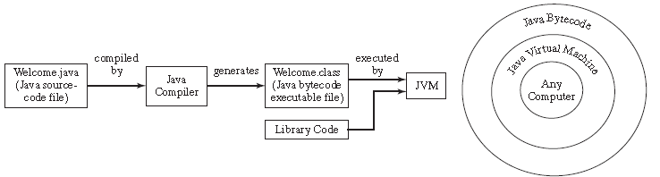

Errors – 3 types pages 20 - 21

* syntax: compile errors: detected by the compiler
* runtime: causes a program to terminate abnormally
* logic: when a program does not perform the way it was intended

Algorithm: page 34, describes how a problem is solved by listing the actions that need to be taken and the order of their execution

Data Types:

* Primitive:
  + int, double, char, boolean
* Reference:
  + String, array

What are the problems with data types? page 66

* Java does not warn of overflows
* floating-point numbers are not stored with complete accuracy

Valid identifier names & conventions pages 39, 40 & 44

What is a variable? page 40, represents a value stored in the computers memory that may be changed in the program

How to declare variables page 36

dataType identifier;

How to assign variables pages 40-41

dataType identifier = value;

Named constants: page 43: final int STAYSTHESAME = 5;

Prompt: directing the user to enter an input, page 38

Declare, assign & use Scanner

What has to be imported to be able to use the Scanner object?

page 38 import java.util.*;

Math operations: page 46 + - * / %

Casting/converions page 56

int x = (int) 8.3;

double y = 9/(double) 8;

page 76 Comparison Operators: <, <=, ==, !=, >, >=

Evaluate: &&, ||, !, ^

if, if…else, if..else if..else statements pages 78 - 87, 93-104

be able to generate a random number, pages 87-88 & 122

Be able to trace through a segment of code

Be able to correct a segment of code

Be able to write a segment of code